**Summary of Textbook**

|  |  |
| --- | --- |
| **Term** | **Definition** |
| Social structures | Stable patterns of social relations |
| Microstructures | Patterns of intimate social relations formed during face-face interactions. (E.g. Family, Friends and Work Associates) |
| Macrostructures | Patterns of social relations that lie outside and above the circle of intimates and acquaintances. Includes classes, bureaucracies and power system such as patriarchy |
| Patriarchy | Traditional system of economic and political inequality between men and women |
| Global structures | Patterns that lie outside the national leve |
| Sociological imagination | Is the quality of mind that enables one to see the connection between personal troubles and social structures |
| Functionalist theory | Stresses that human behaviour is governed by relatively stable social structures. Focus on social stability and problems are solved if there is social solidarity (page 52) |
| Conflict theory | Focus on large macrostructures. Stressed on the upper class trying to maintain advantages while the lower class struggle to increase power. Eliminating upper class will solve conflicts and increase human welfare (page 53) |

Spencer

* Societies evolve as we evolve; and thus societies become from "barbaric" to "civilised".
* Deep social inequalities exist but is normal due to evolution

Durkheim

* Suicides rates vary differently due to different degree of **social solidarity.**
* Social solidarity refers to the degree which group members share beliefs and values and the intensity and frequency of their interaction
* Thus, the more social solidarity the more unlikely people in the group will commit suicides.
* Usually supports functionalism

Marx

* Conflict theory originated from Marx
* Focuses on *class conflict; the struggle between the classes to resist and overcome the opposition of other classes*
* "class consciousness" will develop in suppressed workers and lead to the growth of trade union and labour parties
* Capitalism will eventually collapse
* He feels that communist society will end this conflict.

Weber

* Do not agree with Marx, as he feels that economic circumstances alone is not sufficient for the rise of capitalism

C.Wright Mills

* He feels that power is highly concentrated in the American society, and is less of a democracy as believed

**Power and Authority (Page 444)**

* Power is the ability to control others, even against their will.
* The use of power may be associated with the use of force.
* **Power becomes legitimate when people regard its use as valid or justified.**
* **Power is institutionalised when norms and statuses of social organisations governs its use.**
* **Norms and statuses define how authority should be used, how individuals can achieve authority and how much authority is attached to each status in the organisation.**
* When majority agrees with how the system is being run, raw power becomes authority
* State also regulates citizens in civil society, the private sphere of social life

**Weber**

**Types of Authority:**

1. Traditional: When the rule is in inherited through blood (e.g. China: Mandate of rule, Sultans: Blood of God)
2. Legal-rational authority: Respect for law. (modern societies)
3. Charismatic authority: E.g. Stalin, Hitler or LKY

**Types of political systems**:

Autocracy: Absolute Power, Authoritarian: Shared Power but restricted, Democracy: High degree of Citizen control)

Democracy theories

1. Pluralist theory: Power is widely distributed as no single group exercises disproportionate power. Guarantees democracy

* However, not everyone is fully participated in political movements and thus those who have higher income (and more time) are more influential

1. Elite Theory (Mills) : Power is centred in most influential institutions, and corporate, state and military elites are connected and form close social contacts. (do not form the ruling class as they each have their own set of interests and are in conflicts)

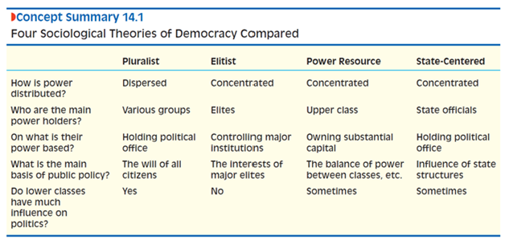

**Culture (Page 102)**

**Culture allow us to create elements to solve practical problems and express our needs, hopes, joys and fears while also constraining us by elements which existed before we are born**

Postmodernism (Page 120)

* Blending cultures, erosion of authority and decline of consensus around some core values

Globalisation is not a new concept, colonialism and missionaries previously also had such effects. It is the reconfigure global forms in local contexts, not "copy and paste".

Examples: the absence of beef and presence of vegetarian burgers in India's MacDonald's'

|  |  |
| --- | --- |
| Term | Definition |
| Culture | is the sum of socially transmitted practices, languages, symbols, beliefs, values, ideologies and material objects people create to deal with real life problems. |
| Ethnocentrism | Judging other culture exclusively by the standard of one's own |
| Culture relativism | A foreign culture should not be judged by the standards of a home culture and should be understood in the cultural context |
| Consumerism | The tendency to define ourselves by the goods and services we purchase. |
| Subculture | A set of distinctive values, norms and practices within a larger culture |
| Counterculture | A subversive subculture that seeks to replace dominant values and opposes them |
| Norms | Accepted ways of doing things in a particular situation |
| Enculturation | Process by which a person learns the requirements of the culture by which he or she is surrounded, and acquires values and behaviours that are appropriate or necessary in that culture |

Weber

* Rationalisation- the application of the most efficient means to achieve given goals and the unintended, negative consequence of doing so.
* It makes modern world living equals to "a iron cage"

Agents of socialisation

* Families (primary socialisation)
* Schools (secondary socialisation)
* Peer groups
* Mass Media

Difference between enculturation and socialisation; in which socialisation is deliberate method to instil teachings which enculturation is without purpose.

Functionalism

* Norms and sanctions to keep society stable, cohesive
* Sees Culture as stable, highly integrated system

Conflict perspective

* Sees Culture as an arena of **social conflict**
* Values and norms help to create and sustain the **privileged position** of the **powerful**
* E.g. Fashion industry (industry owners making profits)

Symbolic interactionism

* Interested in cultural symbols & interaction
* People as active producers and interpreters of Culture
* How people make sense of the world
* Meaning is constructed in social encounters at the micro level

**Families (page 474)**

Decline of traditional nuclear families or nuclear families in most developed societies.

Nuclear family

* A man, a women and at least one child with a socially approved relationship

Traditional Nuclear Family

* Wife works at home without pay and husband work outside for money.

Functionalist View

* The lost of traditional nuclear family has led to increasing social problems such as crime rates and welfare dependency.
* Call out for social reforms to revive back this traditional nuclear family

Murdock

* Functionalist
* Marriage is defined as a socially approved, presumably long-term sexual and economic union between a man and a women.

Nuclear family: *Sexual Activity, Economic Cooperation, Reproduction, Socialisation and Emotional Support*

Conflict and feminist theories

* Families can be structured in many ways due to the demands of new social pressures.
* There is no evidence that the LGBT families raise their children at a disadvantage.
* Changing family forms improves the way people live
* And do not harm as much as functionalists believes.
* Marxist stress how families are tied to the system of capitalist ownership and only the elimination of capitalism can gender inequality in families end
* Problems can be altered through the use of social policies
* And do not harm as much as functionalists think
* Feminists feels that the patriarchy system of power and norms reproduce gender inequality and it exist before communist and capitalist societies.

|  |  |  |
| --- | --- | --- |
| **Liberal Feminism** | **Marxist Feminism** | **Radical Feminism** |
| Primarily concerned with plight of middle and  upper class women and their families.  Women should be given equal opportunities as men.  Equal rights (civil and legal) | Women’s oppression resulting from capitalist exploitation of women through their roles in the family.  Patriarchy as product of capitalism. | Views sexism as most pervasive form of discrimination.  Oppression of women through  (1) domestic labour  (2)sexuality/reproduction  Control over one’s body as essential to women’s liberation. |
|  | Thus only the elimination of capitalism societies will the inequality be eradicated. | Thus supports contraception and abortion rights as well as legislation of domestic and sexual violence |

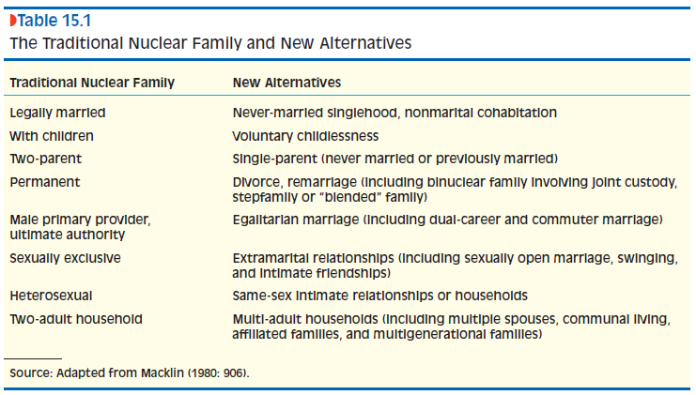

**Race and Ethnicity  (Page 277)**

|  |  |
| --- | --- |
| **Terms** | **Definitions** |
| Prejudice | An attitude that judges a person according to his or her groups' real or imagined characteristics. |
| Discrimination | Unfair treatment of people because of their group membership |
| Race | Category of people whose perceived physical markers are deemed as socially significant |
| Ethnic group | People who perceived cultural markers are deemed socially significant |
| Minority | Socially disadvantaged (do not have to be the majority) |
| Ethnic enclave | Geographical concentration of ethnic group members who establish businesses that serve and employ mainly members of the ethnic group and reinvest profits in community businesses and organisations. |
| Symbolic ethnicity | Nostalgic allegiance to the culture of the immigrant generation, or that of the old country, that is not usually incorporated into everyday behaviour. |
| Racism | Belief that a visible characteristic of a group, such as skin colour, indicates group inferiority and justifies discrimination. |
| Institutional racism | Bias that is inherent in social institutions and is often not noticed by members of the majority group. |
| Segregation | Involves the spatial and institutional separation of racial or ethnic groups |
| Assimilation | Process by which a minority group blends into the majority population and eventually disappears as a distinct group |
| Pluralism | Retention of racial and ethnic culture combined with equal access to basic social resources. |

Although there is no genetic basis of mean intelligence for races, evidences suggests that individual differences in intelligence is partly transmitted through genetics.

Due to globalisation, there is a high level of genetic mixing among various races throughout the world; and people do marry outside there ethnic groups.

Race is a sociological concept as humanity has experienced a lot of intermixing that race as a biological category has no meaning.

Race is used as a tool to establish social inequality and maintain it.

* Sociologists feels that socio-structural conditions rather than values determine the economic success or failure of racial and ethnic groups.
* Example: Koreans or Jews who migrated to America is not due to the values of education, family and hard work but the fact that they are literate, urbanized, and skilled and have money, which facilitated their success as they maintain and build a culture.

Symbolic interaction

* The development of racial and ethnic labels and ethnic identities is typically a process of negotiation. (example even though u identify yourself but others outsiders also impose a label on you, which is then modified, rejected or accepted)

Example of institutional racism: police single out African Americans for car searches, department stores tell their floorwalkers to keep a lookout for African Americans and banks reject their applications more often than whites of the same economic standing

Robert Park (page 331)

* Ecological theory of ethnic succession argues that ethnic groups pass through five stages in their struggle for territory: invasion, resistance, competition, accommodation and cooperation, and assimilation.
* Fails to consider that there are social-structural conditions that prevent some groups from assimilating

Robert Blauner

* Internal colonialism prevents assimilation by segregating the colonized in terms of jobs, housing and social contacts ranging from friendship to marriages.

Bonacich

* Racial identity reinforced in spilt labour markets which will lead to conflict and develops racist attitudes.

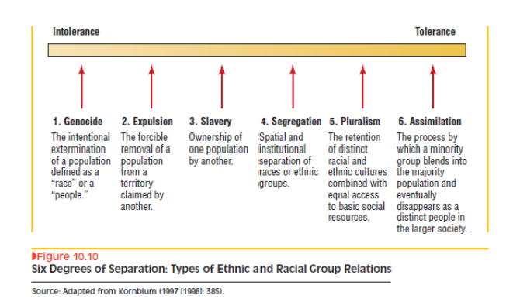

**Gender (page 352)**

|  |  |
| --- | --- |
| **Terms** | **Definitions** |
| Sex | Depends on whether you were born with distinct male or female genitals and a genetic program that released either male or female hormones to stimulate the development of your reproductive system. |
| Gender | Your sense of being male or female and playing masculine and feminine roles in ways defined as appropriate by your culture and society. |
| Gender identity | is one’s identification with, or sense of belonging  to, a particular sex— biologically, psychologically, and socially |
| Gender role | set of behaviours associated with widely shared expectations about how males or females are supposed to act |
| Essentialism | A school of thought that sees gender differences as a reflection of biological differences between women and men |
| Social constructionism | A school of thought that sees gender differences as a reflection of the different social positions occupied by women and men. |
| Glass ceiling | Social barrier which makes it difficult for women to climb up the corporate leader |
| Transgender | Individuals who break society's gender norms by defying the rigid distinction between male and female |
| Transsexual | Believe they were born with the "wrong body" and identify themselves as another sex |
| Homosexuals | People who prefer same sex partners |
| Bisexuals | People who prefer sexual partners of both sexes |

Research shows that babies first develop a vague sense of being a boy or a girl at about the age of 1. They develop a full-blown sense of gender identity between the ages of 2 and 3

Essentialism

* Men and women has the same common goal- to pass on genes into the next generation; but uses different strategies due to the biological differences
* Women tend to invest more than man in ensuring that there is a survival of offspring due to the limited reproductive lifespan.
* However, the biological perspective might not hold as when women take jobs that involve competition or threat, their production of the hormone testosterone is stimulated, causing them to act more aggressively. Aggressiveness is partly role related

**Functionalism and Essentialism**

* Traditional gender roles help to integrate the society.
* Parsons says that women are traditionally specialised to raise children and manage household while men are suppose to work in the paid labour force.
* Enforcement are through gender role socialisation
* For boys, noted Parsons, the essence of masculinity is a series of “instrumental” traits such as rationality, self-assuredness, and competitiveness.
* For girls, the essence of femininity is a series of “expressive” traits such as nurturance and sensitivity to others.
* Boys and girls first learn their respective gender traits in the family as they see their parents going about their daily routines.
* The larger society also promotes gender role conformity. It instils in men the fear that they won’t be attractive to women if they are too feminine, and it instils in women the fear that they won’t be attractive to men if they are too masculine.
* In the functionalist view, then, learning the essential features of femininity and masculinity integrates society and allows it to function properly.

**Social constructionism and symbolic interaction**

* Social constructionism is the view that apparently natural or innate features of life, such as gender, are actually sustained by social processes that vary historically and culturally.
* As such, conflict, symbolic interactionist and feminist theories may be regarded as types of social constructionism.
* As seen in the gender assignment in toys; socialisation in families
* Thorne- children are actively engaged in the process of constructing gender roles. They are not merely passive recipients of adult demands.
* Although schoolchildren tend to segregate themselves by gender, boundaries between boys and girls are sometimes fluid and sometimes rigid, depending on social circumstances. In other words, the content of children’s gendered activities is by no means fixed.

**Class and Stratification (pg 252)**

Thinking questions: What are the sources of social inequality? What patterns of social relations underlie and shape social distribution?

Idea of American being classless has persisted; but subsequent examples in American presidents shows that class persists.

*Class in Marx’s sense of the term is determined by one’s relationship to the means of production. In Weber’s usage, class is determined by one’s “market situation.” Wright distinguishes classes on the basis of relationship to the means of production, amount of property owned, organizational assets, and skill. For Goldthorpe, classes are determined mainly by one’s “employment relations.”*

|  |  |
| --- | --- |
| **Term** | **Definitions** |
| Social Stratification | The way society is organised in layers or strata |
| Vertical social mobility | To movement up or down the stratification system |
| Global inequality | Differences in economic standing of countries |
| Cross-national variations in internal stratification | Differences between countries in their stratification systems |
| Ascription-based stratification | Allocation of rank based on characteristics a person is born with |
| Apartheld | Based on race, prevent marriages between white and blacks and those who are "mixed" race enjoyed privileges |
| Status groups | differ from one another in the prestige or social honour they enjoy and in their lifestyle. |
| **Functional theory of stratification** | argues that (a) some jobs are more important than others, (b) people have to make sacrifices to train for important jobs, and (c) inequality is required to motivate people to undergo these sacrifices. |

Upper-upper class in America

* Less than 1% of population; with majority of their wealth inherited. Have very exclusive lives at expensive private schools, prestige colleges and private clubs.
* Entry has become more easy due to talent of high tech industries, but are still often white and non-hispanic.

Poor-rich/lower-upper class

* Highly educated, survive on income instead of inheritance.

Foraging societies

* Start of human race, food is shared and there is no extra food, thus no rich no poor

Horticultural and Pastoral societies

* Emergence of poor and rich
* As there is the use of small hand tools to cultivate plants and domestication of animals, which created wealth as there is surplus of food

Agrarian Societies

* Agricultural, technological advancement grew surpluses
* Religious beliefs in divine rights, building the caste system
* Hinduism explains caste by saying that there is an afterlife; thus working hard will bring you to an upper caste.

Industrialisation

* Decline in inequality as those who are talented will have bargaining power for more wages
* Union power and political influences can also reduce inequality.

Post-industrial societies

* Social inequality due to technological advancement
* Routine jobs- pay poorly due to little training

Need to differentiate between the wealth and income; you can be wealthy but not have high annual income due to inheritance. As such, income taxes will not be representative into redistribution of wealth.

Marx

* Is unclear on whether the middle class belongs to the upper or lower class.
* The middle class helped stabilise the society as they are also large and heterogeneous.
* Profit motivated capitalists want to concentrate workers in larger and larger factories, keep wages as low as possible, and do not improve working conditions.
* Inequality becomes larger and larger as the capitalist class grew richer and smaller, while working class become larger and poorer.
* Class consciousness would encourage the establishment of the enjoyment of shared wealth.
* **Source (not amount)** of Class: Source of Income: which is the means of production
* Flaw: Technology has improved productivity and help in improving working conditions.

Weber

* Determined by one's "market situation"
* Possession of goods, opportunities for income, level of education, degree of technical skill
* 4 main classes: large property owners, small property owners, property less but highly educated and well paid, property less manual workers.
* Also recognises *Status group* due to their behaviours and lifestyle
* Thus the vulgar "new rich" are often looked down by the well established rich

Davis and Moore

* Some jobs are more importance than others
* **Functional theory of stratification**
* However; difficult to establish which job is more importance
* Inequality can also ignore talents as they cannot support themselves to go to school.

Own thinking

* Class has always been a centre of society; for marriages- brides are expected to come from a family of "equal" standing, which the Chinese proverb suggests.
* Background and family status are often of importance to your own status.
* However, there is an erosion of the family status as some jobs are considered prestigious and allows the individual to "join" the upper class, examples doctors, lawyers.

**Religion**

|  |  |
| --- | --- |
| **Terms** | **Definitions** |
| Collective conscience | composed of the common sentiments and values that people share as a result of living  together. |
| Profane | the secular, everyday world |
| Sacred | religious, transcendent world. |
| Totems | objects that symbolize the sacred. |
| Rituals | public practices designed to connect people to the sacred. |
| Fundamentalists | Interpret their scriptures literally, seek to establish a direct, personal relationship with the higher  being(s) they worship, and are relatively intolerant of non-fundamentalists. |
| Revised secularization Thesis | holds that worldly institutions break off from the  institution of religion over time. As a result, religion governs an ever smaller part of most people’s lives and becomes largely a matter of personal choice. |
| Sect | usually form by breaking away from churches due  to disagreement about church doctrine. Sects are less integrated into society and less bureaucratized than churches. They are often led by charismatic leaders, who tend to be relatively intolerant of religious opinions other than their own. |
| Cults | are small groups of people deeply committed to a religious  vision that rejects mainstream culture and society. |
| Religiosity | Refers to how important religion is to people |

People whose mothers and fathers attended religious services frequently are more likely to do so themselves. Religiosity is a learned behaviour

Islam- Shia are generally more conservative and fundamentalist than the Sunni

Hinduism- vertical social mobility is nearly impossible because striving to move out of one's station in life is inappropriate and ensures reincarnation into lower form.

Buddhism: he rejected Hindu ideas of caste and reincarnation and offered a new way for everyone to achieve spiritual enlightenment. Buddha promised the possibility of salvation to people of low status and women who were marginalised by Hinduism. Adoption due to ability to coexist with local religious practices

William James

* Religion helps us cope with the terrifying fact that we must die
* Offers us immortality, the promise of better times to come, and the security of benevolent spirits who look over us
* Offers meaning and purpose in a world that otherwise seems cruel and senseless

Durkheim

* When people live together, they come to share a common sentiments and values, which forms a collective conscience.
* The effect (or function) of rituals and of religion as a whole is to reinforce social solidarity.
* Religion can maintain social order under some circumstances.
* Fails to consider that religion also creates social conflicts and reinforces social inequality

Marx

* Religion often tranquilizes the underprivileged into accepting their lot in life.
* Creates "false consciousness."
* Religion is then regarded as 'the opium of the people'
* Example: all major religions placed women in a subordinate position; and social inequality due to the will of god
* Civil religion helps to divert attention from the many inequalities that persist in American society.
* Leads to social change

Weber

* Rationalisation leads to organised religion which we bureaucratize religions.
* He argued that religion acts like a railroad switch, determining the tracks along which history will be pushed by the force of political and economic interest.
* Protestantism, for example, invigorated capitalist development.
* Critics note that the correlation between economic development and the predominance of Protestantism is not as strong as Weber thought. They also note that some of Weber’s followers offer one-sided explanations of the role of religion in economic development, which Weber warned against.
* Protestantism encourages people to invest rather than splurge, and also work hard; and this belief system shapes the economic.

**Ageing and elderly (page 395)**

Ageing affects everyone.

Aging is a process of socialisation or learning new roles appropriate to different stages of life. Different societies attach different meanings to the progression of life through its various stages.

Example, in US, menopause is a major life event while in Japan it is a minor matter.

|  |  |
| --- | --- |
| **Terms** | **Definition** |
| Life course | Distinct phrase of life through which people pass. |
| A rite of passage | Ritual that marks the transition of one stage of life to another |
| Life expectancy | Average age at death of the members of the population |
| Age cohort | Category of people born in the same range of years |
| Age roles | Norms and expectations about the behaviour of people of different age cohort |
| Generation | An age group that has unique and formative historical experiences. |
| Age stratification | Social inequality between age cohorts. |
| Gerontocracy | Society ruled by elderly people. |
| Ageism | Prejudice about, and discrimination against elderly people. |

Generation is defined as sociologically an age cohort that has experiences rather than the age group itself.

The very young are at the bottom of the stratification system which people sometimes kills infants to ensure that they themselves can survive. Parents sometimes abandon their children in times of poverty. Even in rich countries, poverty is more widespread among children than adults..

Gerontocracy is present in countries such as South Korean and China.

South Korea- older employees tend to hold more authority and enable to tolerate a younger manager.

Elderly often give up power and is marginalized. Universally culture made people fears old age and misses their youth.

Economic inequality between old man and women are due to women's lower earning power then they are young; as there are some people who are still working as housewives. Lesser retirement benefits for working women as they tend to earn lesser than men.

**Functionalist**

* Preindustrial societies, family, work and community were tightly integrated. Family is the lifeblood of the community as people work in and with their family
* Industrialisation separates work from family as each age cohorts has distinct functions.
* Industrialisation also raised the standards of living and created other conditions that led to increased in life expectancy, leading to increased in proportion of the old.
* Age stratification occurred as different age cohorts performed functions of differing value to the society.
* Elderly in the preindustrial societies, elderly were viewed as those with wisdom and knowledge, but industrialisation made them less important.

**Conflict Theory**

* Agree with the functionalists that industrialisation created distinct categories of youth and the elderly.
* However, age stratification does not reflect the functional importance of different age cohort but rather is due to the competition and conflict.
* Young people overthrow and seize power, elderly organise themselves politically to decrease their disadvantages and increase their advantages in life.
* Competition and conflict redistribute power and wealth between age cohorts rather than roles that are important or not.
* They also do not agree that there is problem of convergence, as political struggles can decide how much age stratification exists in a society. Class stratification can decide how much age stratification there is in the society.

**Symbolic interactionist theory**

* The way which people understand ageing is a matter of interpretation.
* Found out that young people are overrepresented in media while elderly is underrepresented and is always portrayed as unintelligent, unattractive and unfriendly.

Psychiatrist Elisabeth Kubler-Ross

* Analysis of stages of dying in contemporary America
* How reluctant we are to accept death
* Patients went into denial, refusing that their death is imminent due to an incurable disease.
* Then they expressed anger that their death is unjust.
* Negotiation to plead with god or fate to delay death
* Depression- resign to fate but deeply despondent
* Acceptance, expressing regret and putting their affairs into order.

**Deviance and Crime**

United States can be considered to be obsessed with crime due to the focus on it on the media.

Definitions of crime and deviance changes over time; as seen in homosexuality which it used to be considered a crime and then a sickness; but now is legally recognised as a sexual orientation.

The viewpoint of whether one thing is deviance or a crime depends on various groups; in the eyes of the law enforcement, riots which demands freedom or rights is considered a crime, while for rioters involved it is considered as not deviant.

|  |  |
| --- | --- |
| Term | Definition |
| Deviance | Someone departs from a norm |
| Informal punishment | Mild sanction that is imposed during face-to-face interaction rather than the judicial system |
| Stigmatization | Negatively evaluated because of a marker that distinguished them from others. |
| Formal punishment | Judicial system penalised someone for breaking a law |
| White collar crimes | Illegal acts committed by a person of respectability and high social status in the course of his or her occupation. |
| Street crimes | Includes arson, burglary, assault and other illegal acts disproportionately committed by people from lower classes. |
| Victimless crimes | Involves violations of the law which no victim has stepped forward and been identified; such as illegal drug use and prostitution |
| Social control | Social sanctions by means of which conformity to cultural guidelines is ensured. |
| Motivational theories | Identify the social factors that drive people to commit deviance and crime |
| Constraint theories | Identify the social factors that impose deviance and crime or conventional behaviour on people. |
| Strain theory | People may turn to deviance when they experience strain as the culture values material success and society fails to provide enough opportunities for everyone to succeed. |
| Subcultural theory | Gangs are a collective adaption to social conditions. Distinct norms and values that reject the legitimate world crystallise in gangs. |
| Techniques of neutralisation | Rationalisation that deviants and rationalisations use to justify their activities. These techniques make deviance and crime seems normal, at least to the deviants and criminals themselves. |
| Differential association | Holds that people learn to value deviant or nondeviant lifestyles depending on whether their social environment leads them to associate more with deviants or nondeviants. |
| Control theory | Rewards of deviant and crime are ample and thus people will do it if they could get away with it. |
| Labelling theory | Deviance results not so much from the actions of the deviant as from the response of the others, who label them as so. |
| Conflict theories of deviance and crime | Arises out of conflict between the power and the powerless. |
| Moral panic | Many people believe that some form of deviance or crime poses a profound threat to society's well-being. |

John Hagen

* classifies various types of deviance and crime along three dimensions.
* First dimension involves the severity of the social response
* Second dimension involves the perceived harmfulness of the deviant or criminal act. (actual harmfulness may not be important, but the perceived harmfulness is)
* Third dimension is the degree of public agreement on whether an act should be considered deviant.  Note: social definition of major crimes such as murder can change across culture and societies. For example: Eskimos allow new-borns to freeze to death sometimes.
* 4 types of deviance and crime:
  + Social diversions are minor acts of deviance such as participating in fads and fashion, people usually perceive these acts as harmless
  + Social deviations are more serious acts and large proportion of the people agree that they are deviant and somewhat harmful. These are usually subjected to institutional sanctions.
  + Conflict crimes are deviant acts which the state defines as illegal, but the definition is controversial in the wider society.
  + Consensus crime are widely recognised to be bad in themselves but there is controversy over their seriousness and majority of the people agree that such crimes should have serious punishment.

Weber

* Power is a crucial element in the social construction of deviance and crime
* Power is the "probability that one actor within a social relationship will be in a position to carry out his (or her) own will despite resistance."
* Relatively powerful groups will be able to create norms and laws that suit their interests.
* Relatively powerless social groups will be unable to do.

Rape is increasingly prosecuted due to increasing influential power by women. Sexual harassment is now considered a crime and a deviation due to the redistribution of power.

Becker

* Observed Musicians have to pass 3 stages to become a regular user.
* Learning to smoke the drug in a way which produce the real effects, learning to recognise the effects and connect them with drug use and Learning to enjoy the perceived sensations
* Meaning motive and opportunity is not the only things needed for learning deviant or criminal behaviour.

Functionalist approach

Durkheim:

* Deviance is normal because it is needed and exist in all societies as it gives people the chance to define what is moral and what is not.
* Allows us to draw moral boundaries; and to promote social solidarity.
* Deviance can also promote healthy social change
* Today's deviance can be tomorrow's morality, which some acts that violate norms suggests new paths for moral development.
* Absence of clear norms, "anomie" can lead to elevated levels of suicides and other form of deviant behaviour.

Merton (pg 235)

* Cultures often teach people to value material success
* And do not provide enough legitimate opportunities for everyone to succeed.
* Some people experiences strain and force themselves to adhere to social norms despite the strain (conformity)
* Those who do not adapt will drop out of the conventional society (retreatism)
* Can reject the goals of the conventional society but continue to follow its rules (ritualism)
* And protest against convention and support alternative values (rebellion)
* Find alternative and illegal ways to support alternative values (innovation)

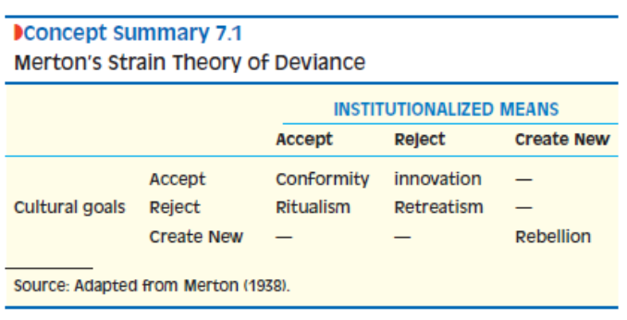

 Subcultures

* Justifies their illegal activities to make them appear morally acceptable and normal.
* Deny personal responsibility for their actions.
* Deviance is discouraged within the subcultures.

Symbolic Interaction Approach

Labelling of people who act in a deviant way.

 Control theory can explain gender differences in crime as families exert more control over girls than over boy with more supervision.

Conflict theory

Spitzer: capitalist societies are based on private ownership of property. Smooth functioning depends on the availability of productive labour and respect for authority, and when a crime challenge private property it is a crime.

